

Percobaan I

Judul Modul Praktikum
Nama Praktikan (13212XXX)
Asisten : Nama Asisten (13211XXX)
Tanggal Percobaan : DD/MM/YYYY
EL3111 Praktikum Arsitektur Sistem Komputer
Laboratorium Sinyal dan Sistem – Sekolah Teknik Elektro dan Informatika
Institut Teknologi Bandung
Abstrak—These instructions give you guidelines for preparing papers for IEEE Transactions and Journals. Use this document as a template if you are using Microsoft Word 6.0 or later. Otherwise, use this document as an instruction set. The electronic file of your paper will be formatted further at IEEE. Paper titles should be written in uppercase and lowercase letters, not all uppercase. Avoid writing long formulas with subscripts in the title; short formulas that identify the elements are fine (e.g., "Nd–Fe–B"). Do not write “(Invited)” in the title. Full names of authors are preferred in the author field, but are not required. Put a space between authors’ initials. Define all symbols used in the abstract. Do not cite references in the abstract. Do not delete the blank line immediately above the abstract; it sets the footnote at the bottom of this column.

Kata Kunci—Enter key words or phrases in alphabetical order, separated by commas.

Pendahuluan
T
HIS document is a template for Microsoft Word versions 6.0 or later. If you are reading a paper or PDF version of this document, please download the electronic file,
TRANS-JOUR.DOC, from the IEEE Web site at http://www.ieee.org/web/publications/authors/transjnl/index.html so you can use it to prepare your manuscript. If you would prefer to use LATEX, download IEEE’s LATEX style and sample files from the same Web page. Use these LATEX files for formatting, but please follow the instructions in TRANS-JOUR.DOC or TRANS-JOUR.PDF.
If your paper is intended for a conference, please contact your conference editor concerning acceptable word processor formats for your particular conference.

Landasan Teoretis
When you open TRANS-JOUR.DOC, select “Page Layout” from the “View” menu in the menu bar (View | Page Layout), (these instructions assume MS 6.0. Some versions may have alternate ways to access the same functionalities noted here). Then, type over sections of TRANS-JOUR.DOC or cut and paste from another document and use markup styles. The pull-down style menu is at the left of the Formatting Toolbar at the top of your Word window (for example, the style at this point in the document is “Text”). Highlight a section that you want to designate with a certain style, then select the appropriate name on the style menu. The style will adju st your fonts and line spacing. Do not change the font sizes or line spacing to squeeze more text into a limited number of pages. Use italics for emphasis; do not underline.
To insert images in Word, position the cursor at the insertion point and either use Insert | Picture | From File or copy the image to the Windows clipboard and then Edit | Paste Special | Picture (with “float over text” unchecked).
IEEE will do the final formatting of your paper. If your paper is intended for a conference, please observe the conference page limits.

Subbab Landasan Teoretis 1
Define abbreviations and acronyms the first time they are used in the text, even after they have already been defined in the abstract. Abbreviations such as IEEE, SI, ac, and dc do not have to be defined. Abbreviations that incorporate periods should not have spaces: write “C.N.R.S.,” not “C. N. R. S.” Do not use abbreviations in the title unless they are unavoidable (for example, “IEEE” in the title of this article).

Subbab Landasan Teoretis II
Use one space after periods and colons. Hyphenate complex modifiers: “zero-field-cooled magnetization.” Avoid dangling participles, such as, “Using (1), the potential was calculated.” [It is not clear who or what used (1).] Write instead, “The potential was calculated by using (1),” or “Using (1), we calculated the potential.”
Use a zero before decimal points: “0.25,” not “.25.” Use “cm³,” not “cc.” Indicate sample dimensions as “0.1 cm × 0.2 cm,” not “0.1 × 0.2 cm².” The abbreviation for “seconds” is “s,” not “sec.” Use “Wb/m²” or “webers per square meter,” not “webers/m².” When expressing a range of values, write “7 to 9” or “7-9,” not “7~9.”

Hasil dan Analisis
If you are using Word, use either the Microsoft Equation Editor or the MathType add-on (http://www.mathtype.com) for equations in your paper (Insert | Object | Create New | Microsoft Equation or MathType Equation). “Float over text” should not be selected.
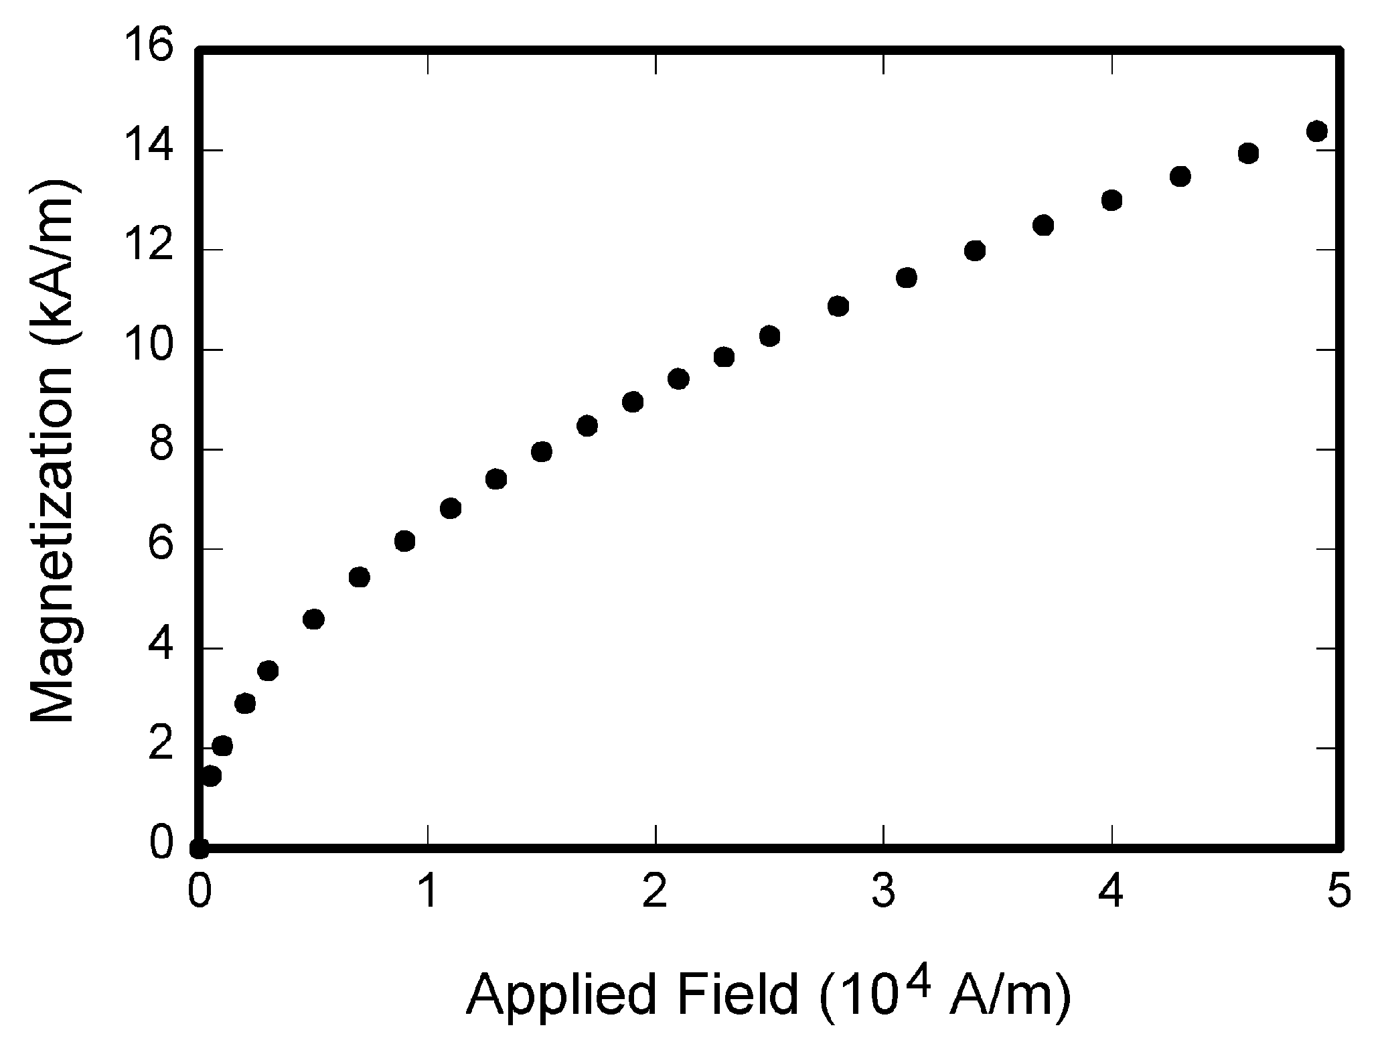
Fig. 1. Magnetization as a function of applied field. Note that “Fig.” is abbreviated. There is a period after the figure number, followed by two spaces. It is good practice to explain the significance of the figure in the caption.

Tugas I : Judul Tugas
Number equations consecutively with equation numbers in parentheses flush with the right margin, as in (1). First use the equation editor to create the equation. Then select the “Equation” markup style. Press the tab key and write the equation number in parentheses. To make your equations more compact, you may use the solidus ( / ), the exp function, or appropriate exponents. Use parentheses to avoid ambiguities in denominators. Punctuate equations when they are part of a sentence, as in

(1)

Be sure that the symbols in your equation have been defined before the equation appears or immediately following. Italicize symbols (T might refer to temperature, but T is the unit tesla). Refer to “(1),” not “Eq. (1)” or “equation (1),” except at the beginning of a sentence: “Equation (1) is ... .”

Tugas 2 : Judul Tugas
Number equations consecutively with equation numbers in parentheses flush with the right margin, as in (1). First use the equation editor to create the equation. Then select the “Equation” markup style. Press the tab key and write the equation number in parentheses. To make your equations more compact, you may use the solidus ( / ), the exp function, or appropriate exponents. Use parentheses to avoid ambiguities in denominators. Punctuate equations when they are part of a sentence, as in

Tugas 3 : Judul Tugas
Number equations consecutively with equation numbers in parentheses flush with the right margin, as in (1). First use the equation editor to create the equation. Then select the “Equation” markup style. Press the tab key and write the equation number in parentheses. To make your equations more compact, you may use the solidus ( / ), the exp function, or appropriate exponents. Use parentheses to avoid ambiguities in denominators. Punctuate equations when they are part of a sentence, as in

Tugas 4: Judul Tugas
Number equations consecutively with equation numbers in parentheses flush with the right margin, as in (1). First use the equation editor to create the equation. Then select the “Equation” markup style. Press the tab key and write the equation number in parentheses. To make your equations more compact, you may use the solidus ( / ), the exp function, or appropriate exponents. Use parentheses to avoid ambiguities in denominators. Punctuate equations when they are part of a sentence, as in
Contoh untuk menampilkan figure berupa gambar (screenshot) adalah sebagai berikut. Gambar yang terlalu lebar akan lebih baik bila ditampilkan pada lampiran.
Contoh penulisan tabel sebagai berikut.
TABLE I
Units for Magnetic Properties
Symbol | Quantity | Conversion from Gaussian and  CGS EMU to SI ª
Φ | magnetic flux | 1 Mx → 10⁻⁸ Wb = 10⁻⁸ V·s
B | magnetic flux density,  magnetic induction | 1 G → 10⁻⁴ T = 10⁻⁴ Wb/m²
H | magnetic field strength | 1 Oe → 10³/(4π) A/m
m | magnetic moment | 1 erg/G = 1 emu  → 10⁻³ A·m² = 10⁻³ J/T
M | magnetization | 1 erg/(G·cm³) = 1 emu/cm³  → 10³ A/m
4πM | magnetization | 1 G → 10³/(4π) A/m
σ | specific magnetization | 1 erg/(G·g) = 1 emu/g → 1 A·m²/kg
j | magnetic dipole  moment | 1 erg/G = 1 emu  → 4π × 10⁻¹⁰ Wb·m
J | magnetic polarization | 1 erg/(G·cm³) = 1 emu/cm³  → 4π × 10⁻⁴ T
χ, κ | susceptibility | 1 → 4π
χ_{ρ} | mass susceptibility | 1 cm³/g → 4π × 10⁻³ m³/kg
μ | permeability | 1 → 4π × 10⁻⁷ H/m  = 4π × 10⁻⁷ Wb/(A·m)
μ_{r} | relative permeability | μ → μ_{r}
w, W | energy density | 1 erg/cm³ → 10⁻¹ J/m³
N, D | demagnetizing factor | 1 → 1/(4π)
Vertical lines are optional in tables. Statements that serve as captions for the entire table do not need footnote letters.
ªGaussian units are the same as cg emu for magnetostatics; Mx = maxwell, G = gauss, Oe = oersted; Wb = weber, V = volt, s = second, T = tesla, m = meter, A = ampere, J = joule, kg = kilogram, H = henry.

Simpulan
- Use either SI (MKS) or CGS as primary units. (SI units are strongly encouraged.) English units may be used as secondary units (in parentheses).
- This applies to papers in data storage. For example, write “15 Gb/cm² (100 Gb/in²).” An exception is when English units are used as identifiers in trade, such as “3½-in disk drive.” Avoid combining SI and CGS units, such as current in amperes and magnetic field in oersteds.
- This often leads to confusion because equations do not balance dimensionally.
- If you must use mixed units, clearly state the units for each quantity in an equation.
- The SI unit for magnetic field strength H is A/m.
- However, if you wish to use units of T, either refer to magnetic flux density B or magnetic field strength symbolized as µ₀H.
- Use the center dot to separate compound units, e.g., “A·m².”

Referensi
Basic format for books:
- J. K. Author, “Title of chapter in the book,” in Title of His Published Book, xth ed. City of Publisher, Country if not
- USA: Abbrev. of Publisher, year, ch. x, sec. x, pp. xxx–xxx.
Examples:
- G. O. Young, “Synthetic structure of industrial plastics,” in Plastics, 2nd ed., vol. 3, J. Peters, Ed. New York: McGraw-Hill, 1964, pp. 15–64.
- W.-K. Chen, Linear Networks and Systems. Belmont, CA: Wadsworth, 1993, pp. 123–135.

Basic format for periodicals:
- J. K. Author, “Name of paper,” Abbrev. Title of Periodical, vol. x, no. x, pp. xxx-xxx, Abbrev. Month, year.
Examples:
- J. U. Duncombe, “Infrared navigation—Part I: An assessment
of feasibility,” IEEE Trans. Electron Devices, vol. ED-11, no. 1, pp. 34–39, Jan. 1959.
- E. P. Wigner, “Theory of traveling-wave optical laser,” Phys. Rev.,
vol. 134, pp. A635–A646, Dec. 1965.
- E. H. Miller, “A note on reflector arrays,” IEEE Trans. Antennas Propagat., to be published.

Basic format for reports:
- J. K. Author, “Title of report,” Abbrev. Name of Co., City of Co., Abbrev. State, Rep. xxx, year.
Examples:
- E. E. Reber, R. L. Michell, and C. J. Carter, “Oxygen absorption in the earth’s atmosphere,” Aerospace Corp., Los Angeles, CA, Tech. Rep. TR-0200 (4230-46)-3, Nov. 1988.
- J. H. Davis and J. R. Cogdell, “Calibration program for the 16-foot antenna,” Elect. Eng. Res. Lab., Univ. Texas, Austin, Tech. Memo. NGL-006-69-3, Nov. 15, 1987.

Basic format for handbooks:
- Name of Manual/Handbook, x ed., Abbrev. Name of Co., City of Co., Abbrev. State, year, pp. xxx-xxx.
Examples:
- Transmission Systems for Communications, 3rd ed., Western Electric Co., Winston-Salem, NC, 1985, pp. 44–60.
- Motorola Semiconductor Data Manual, Motorola Semiconductor Products Inc., Phoenix, AZ, 1989.

Basic format for books (when available online):
- Author. (year, month day). Title. (edition) [Type of medium]. volume (issue). Available: site/path/file
Example:
- J. Jones. (1991, May 10). Networks. (2nd ed.) [Online]. Available: http://www.atm.com

Basic format for journals (when available online):
- Author. (year, month). Title. Journal. [Type of medium]. volume (issue), pages. Available: site/path/file
Example:
- R. J. Vidmar. (1992, Aug.). On the use of atmospheric plasmas as electromagnetic reflectors. IEEE Trans. Plasma Sci. [Online]. 21(3), pp. 876–880. Available: http://www.halcyon.com/pub/journals/21ps03-vidmar

Basic format for papers presented at conferences (when available online):
- Author. (year, month). Title. Presented at Conference title. [Type of Medium]. Available: site/path/file
Example:
- PROCESS Corp., MA. Intranets: Internet technologies deployed behind the firewall for corporate productivity. Presented at
INET96 Annual Meeting. [Online]. Available: http://home.process.com/Intranets/wp2.htp

Basic format for reports and handbooks (when available online):
- Author. (year, month). Title. Comp an y . C ity, State or Country. [Type of Medium]. Available: site/path/file
Example:
- S. L. Tall een. (1996 , Apr . ). The In t r an et Archi -tecture: M a nagi ng i n f o rm at i on i n t h e ne w paradigm. Amdahl Corp., CA. [Online]. Available: http://www.amdahl.com/doc/products/bsg/intra/infra/html

Basic format for computer programs and electronic documents (when available online): ISO recommends that capitalization follow the accepted practice for the language or script in which the information is given.
Example:
- A. Harriman. (1993, June). Compendium of genealogical software. Humanist. [Online]. Available e-mail: HUMANIST@NYVM.ORG Message: get GENEALOGY REPORT

Basic format for patents (when available online):
- Name of the invention, by inventor’s name. (year, month day). Patent Number [Type of medium]. Available: site/path/file
Example:
- Musical toothbrush with adjustable neck and mirror, by L.M.R. Brooks. (1992, May 19). Patent D 326 189
[Online]. Available: NEXIS Library: LEXPAT File: DESIGN

Basic format for conference proceedings (published):
- J. K. Author, “Title of paper,” in Abbreviated Name of Conf., City of Conf., Abbrev. State (if given), year, pp. xxxxxx.
Example:
- D. B. Payne and J. R. Stern, “Wavelength-switched pas- sively coupled single-mode optical network,” in Proc. IOOC-ECOC, 1985,
pp. 585–590.
Example for papers presented at conferences (unpublished):
- D. Ebehard and E. Voges, “Digital single sideband detection for interferometric sensors,” presented at the 2nd Int. Conf. Optical Fiber Sensors, Stuttgart, Germany, Jan. 2-5, 1984.

Basic format for patents:
- J. K. Author, “Title of patent,” U.S. Patent x xxx xxx, Abbrev. Month, day, year.
Example:
- G. Brandli and M. Dick, “Alternating current fed power supply,”
U.S. Patent 4 084 217, Nov. 4, 1978.
Basic format for theses (M.S.) and dissertations (Ph.D.):
- J. K. Author, “Title of thesis,” M.S. thesis, Abbrev. Dept., Abbrev. Univ., City of Univ., Abbrev. State, year.
- J. K. Author, “Title of dissertation,” Ph.D. dissertation, Abbrev. Dept., Abbrev. Univ., City of Univ., Abbrev. State, year.
Examples:
- J. O. Williams, “Narrow-band analyzer,” Ph.D. dissertation, Dept. Elect. Eng., Harvard Univ., Cambridge, MA, 1993.
- N. Kawasaki, “Parametric study of thermal and chemical nonequilibrium nozzle flow,” M.S. thesis, Dept. Electron. Eng., Osaka Univ., Osaka, Japan, 1993.
Basic format for the most common types of unpublished references:
- J. K. Author, private communication, Abbrev. Month, year.
- J. K. Author, “Title of paper,” unpublished.
- J. K. Author, “Title of paper,” to be published.
Examples:
- A. Harrison, private communication, May 1995.
- B. Smith, “An approach to graphs of linear forms,” unpublished.
- A. Brahms, “Representation error for real numbers in binary computer arithmetic,” IEEE Computer Group Repository, Paper R-67-85.

Basic format for standards:
- Title of Standard, Standard number, date.
Examples:
- IEEE Criteria for Class IE Electric Systems, IEEE Standard 308, 1969.
- Letter Symbols for Quantities, ANSI Standard Y10.5-1968.

Lampiran
- Source code untuk tugas I
-- Praktikum EL3111 Arsitektur Sistem Komputer
-- Modul : 6
-- Percobaan : 1
-- Tanggal : 2 Desember 2013
-- Kelompok : VI
-- Rombongan : A
-- Nama (NIM) 1 : Audra Fildza Masita (13211008)
-- Nama (NIM) 2 : Bagus Hanindhito (13211007)
-- Nama File : top_level_mips.vhd

LIBRARY ieee;
USE ieee.std_logic_1164.all;

ENTITY top_level_mips IS
PORT (
clk : IN STD_LOGIC;
rst : IN STD_LOGIC;
ALU_result : OUT STD_LOGIC_VECTOR (31 DOWNTO 0);
PCoutTest : OUT STD_LOGIC_VECTOR (31 DOWNTO 0);
PCinTest : OUT STD_LOGIC_VECTOR (31 DOWNTO 0);
instrout : OUT STD_LOGIC_VECTOR (31 DOWNTO 0);
sgnALUSrcout : OUT STD_LOGIC_VECTOR (1 DOWNTO 0);
sgnsignimmout : OUT STD_LOGIC_VECTOR (31 DOWNTO 0);
sgnBranchResultout : OUT STD_LOGIC;
sgnoutalu2out : OUT STD_LOGIC_VECTOR (31 DOWNTO 0);
sgnoutshift2out : OUT STD_LOGIC_VECTOR (31 DOWNTO 0);
sgnMemWriteout : OUT STD_LOGIC;
sgnMemReadout : OUT STD_LOGIC;
sgnRead_Mem1out : OUT STD_LOGIC_VECTOR (7 DOWNTO 0);
sgnMemToRegOut : OUT STD_LOGIC

);
END top_level_mips;

- Screenshot hasil tugas 2
